Day 3 Linux: Network Basic

Get me IP address of particular domain (guvi.in) How do I find my CPU/memory usage of my server? Test the connectivity between 2 nodes? I have deployed an application in guvi.com:9000, and logs shows my app is running, but I’m unable to view the page. Check whether my port is open or not?

1. Get Ip address of domain guvi.in

Command: nslookup guvi.in

Ip Address: 172.67.70.207 , 104.26.5.88 , 104.26.4.88

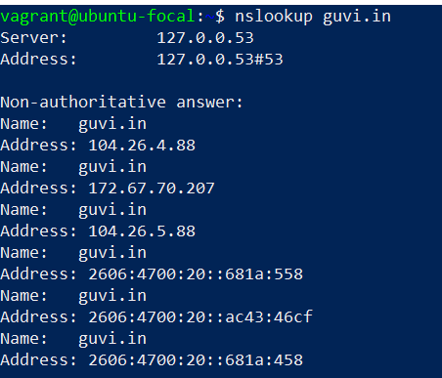

1. Find my CPU/memory usage of my server.

Command: top

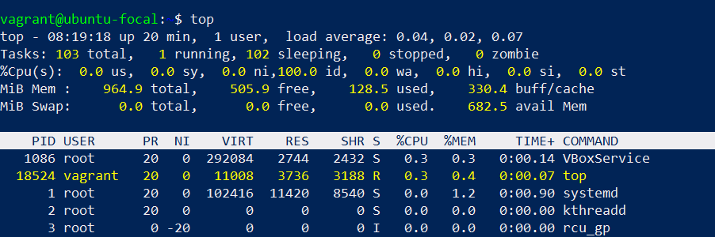

1. Test the connectivity between 2 nodes?

Command: ping guvi.in

I am able to ping guvi.in from my system

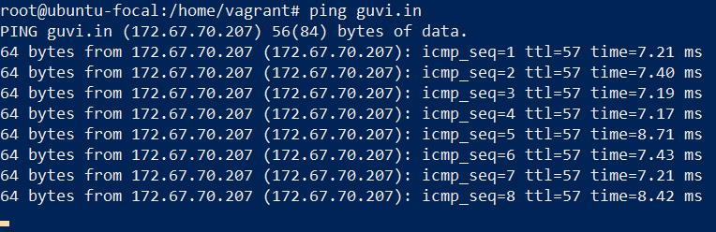

1. Check whether the port is close or open – It is in **filtered** state when I try using telnet command it was just giving me trying only unable to reach .so I used nmap command in that it’s showing filtered while I used 80 port its says open

Command: nmap -p 9000 guvi.com

